EPISCOPAL DIOCESE OF OKLAHOMA

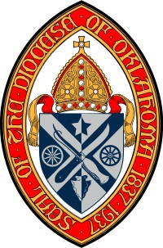

2021 Bi-Vo Priest Retreat
February 20, 2021

Saturday, February 20th
8:30 Welcome by Bishop Poulson
8:45 First Reflection - Scripture and Tradition:
The Ministry of a Priest

9:45 Break

10:00 Second Reflection - The Ordination of a Priest

11:00 Canonical Review - The Life and Ministry of a Priest
11:30 Time of Sharing
12:45 Final Comments - Bishop Poulson
1:00 Wrap up and dismissal

