Christian Formation Ideas for March, 2019
Welcome to my new resource! If you are in a small congregation or do not have someone in charge of Christian Formation, these resource sheets will provide you with information about the various holidays during the month and some ideas to celebrate.
If you have any questions or ideas, please share with me at sevans@epiok.org
March 5 Shrove Tuesday
Celebrated the day before Ash Wednesday, Shrove Tuesday (also called “Pancake Tuesday” or “Pancake Day”) is the final day before the 40-day period of Lent begins.

Its name comes from the Germanic-Old English word “shrive,” meaning absolve, and it is the last day of the liturgical season historically known as Shrovetide. Because it comes directly before Lent, a season of fasting and penitence, this was the day that Christians would go to be “shriven” by their confessor.

Shrove Tuesday also became a day for pre-fasting indulgence. In particular, the need to use up rich ingredients such as butter, milk, sugar and eggs before Lent gave rise to the tradition of eating pancakes on this day.

There are even historical references to a “pancake bell” in English towns being rung around 11 a.m. on this day to signal that it was time to get frying.

For Anglican churches across Canada, Shrove Tuesday means gathering for a pancake supper. Many churches host dinners or luncheons, serving pancakes usually with a range of toppings, fruit and sides like bacon or sausages. Visitors are usually asked to give a small contribution or freewill offering.

Did you know that the ashes used are from the previous year’s Palm branches?

While the palms need to be attended to before Ash Wednesday, it could be a nice way to end the
Shrove Tuesday event by a group Burning of the Ashes. Buildingfaith has information on doing this at
https://www.buildfaith.org/ashes-burning-palms-confirmation-class/#gref

March 6 Ash Wednesday
The first of the forty days of Lent, named for the custom of placing blessed ashes on the foreheads of
worshipers at Ash Wednesday services. The ashes are a sign of penitence and a reminder of mortality,
and may be imposed with the sign of the cross. Ash Wednesday is observed as a fast in the church year
of the Episcopal Church. The Ash Wednesday service is one of the Proper Liturgies for Special Days in the
BCP (p. 264). Imposition of ashes at the Ash Wednesday service is optional.

March 17 St. Patrick’s Day

Each year the Episcopal Church celebrates the Feast Day of Saint Patrick, fifth century bishop and
missionary of Ireland, on March 17, the day of his death in 461. Holy Women, Holy Men (Church
Publishing, 2010) relates that Patrick was born on the northwest coast of Britain in about 390. His
grandfather had been a Christian priest, and his father was a deacon in the early Christian church. When
Patrick was a teenager, he was captured by a band of Irish slavers and was forcibly taken to Ireland to
serve as a shepherd. When Patrick was in his early 20s, he escaped and returned to Britain, where he
was educated as a Christian. After taking holy orders as both presbyter and bishop, he had a vision,
calling him to return to Ireland. Sometime around the year 431, when Patrick returned to Ireland, he
began converting Irish pagans into Christians by appealing to the local kings, and through them to their
tribes. Patrick built Christian churches over sacred pagan sites, carved crosses on old druidic pillars, and
protected sacred wells and springs with Christian saints.

One of the legends about Saint Patrick is that he illustrated the doctrine of the Holy Trinity to the Irish by
using a shamrock, a three-leafed plant sacred in pagan tradition. Shamrocks remain a central symbol for
Saint Patrick’s Day.

A group activity could include baking pretzels (and eating them!). Pretzels have three holes in them,
which can help reinforce the trinity.
https://www.kingarthurflour.com/recipes/hot-buttered-soft-pretzels-recipe

Or use canned biscuits, roll and extend into a “snake” shape and then cross the arms over.

If you want to celebrate St. Patrick’s Day, ask everyone to wear something green that Sunday.

Did you know? Legend has it that St. Patrick supposedly was responsible for ridding Ireland of snakes? It is said that St. P chased the slithering reptiles into the sea after they began attacking him during a 4-day fast he took on top of a hill.

It's admittedly an unlikely tale. Ireland is one of only a handful of places worldwide—including New Zealand, Iceland, Greenland, and Antarctica—that Indiana Jones and other snake-averse humans can visit without fear.

But snakes were certainly not chased out of Ireland by St. Patrick, who had nothing to do with Ireland's snake-free status, Nigel Monaghan, keeper of natural history at the National Museum of Ireland in Dublin, told National Geographic.

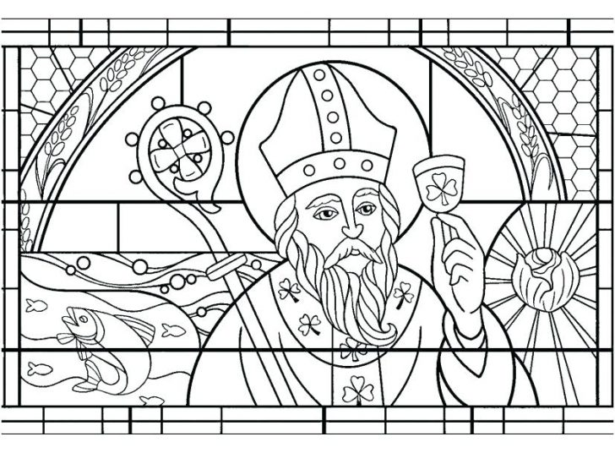

Use this shamrock to write your prayers for March. Then color.

